USER MANUAL
ZAMBISA WARRIOR
Annas Isa
March 2021

Table of Contents
1 GENERAL INFORMATION 3
1.1 System Overview 3
1.2 Project References 3
1.3 Authorized Use Permission 3
1.4 Point of Contact 3
1.5 Manual Version 3
1.6 Acronyms and Abbreviations 3
2 SYSTEM SUMMARY 3
2.1 System Configuration 3
2.2 Data Flow 4
2.3 User Access Levels 4
3 PLAYING THE GAME 4
3.1 Starting the Game 4
3.2 User Controls 5
3.3 Action Controls 7
3.4 Pause/Play 7
3.5 Exiting the Game 8
4 Back Story 8

GENERAL INFORMATION

System Overview
A web game:
- A software system based on Visual Studio Code environment
- Web game for recreation
- Developed using Google Chrome search engine
- Operational Status:
  - Fully operational
  - Under development

Project References
P.S User manual template was gotten from previous project (Brimo’s Sea).
Art:
https://opengameart.org
https://www.kenney.nl
https://itch.io
Sound:
https://opengameart.org
https://www.youtube.com/watch?v=BLURv5R2XfU
Texture Packer:
https://www.codeandweb.com/texturepacker
Sprite Trimmer (Piskel):
https://www.piskelapp.com

Authorized Use Permission
I, Annas Isa, the author of this application permits everyone who has access to the source code to use it in any way they see fit.

Point of Contact
You can contact me at phone: +12042239914 or email: aisa1@athabasca.edu for any help with further information about the software or any troubleshooting aid.

Manual Version
User Manual v1.0

Acronyms and Abbreviations
Application – App

SYSTEM SUMMARY

System Configuration
I created the game using the Phaser.io framework. With Phaser.io, I created animations using scenes. All the scenes created extended “Phaser.Scene”. Which is a base class from the phaser package. This web app consists of various scenes embedded on a canvas placed on an HTML page. This application is run using the Node.js framework and as a result is served up locally with npm.

Data Flow
This system receives input on the main menu through the mouse pointer, handled by a Button.js class. During the game, the player gets input through some keys on the keyboard mapped to actions. The enemies use a simple AI logic to function. The following diagram gives a graphical representation of my data flow:
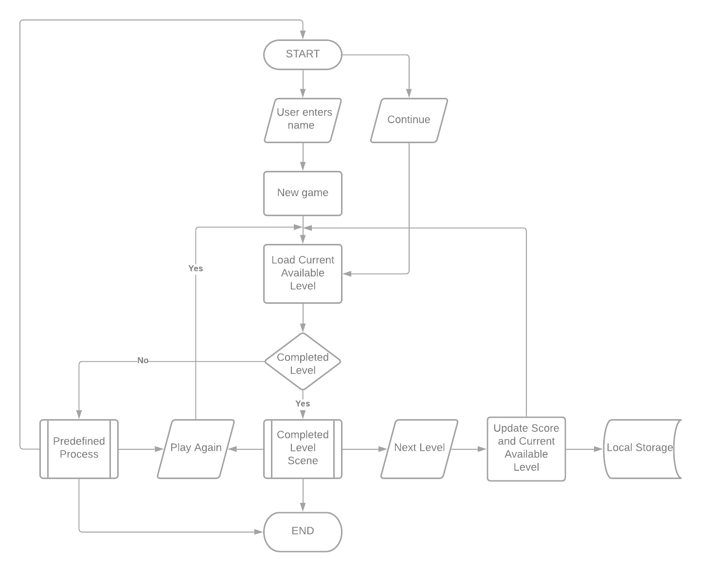

User Access Levels
The primary users of this app are the consumers, who have access to the app through installation. Secondary users are the professors who have access to all the source files and have the authorization to make appropriate changes/adjustments however they see fit.

PLAYING THE GAME

Starting the Game
At the user launch of the game, the Home page comes into view. A user would have to tap the “New game” or “Continue” to begin the game.
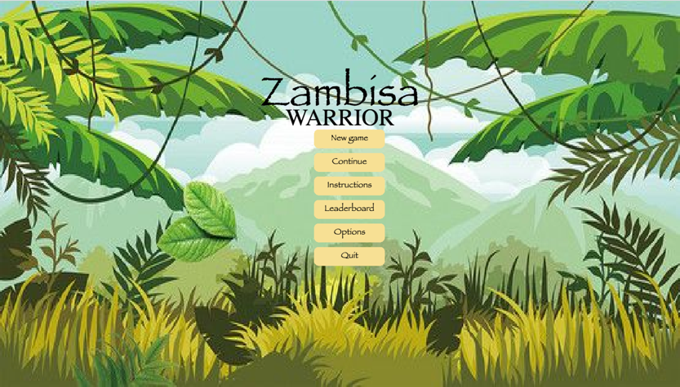
Onclick of the “New game” button, the app prompts the user for a username. After the username has been typed in, proceed to click on the “Submit” button to begin a game session.
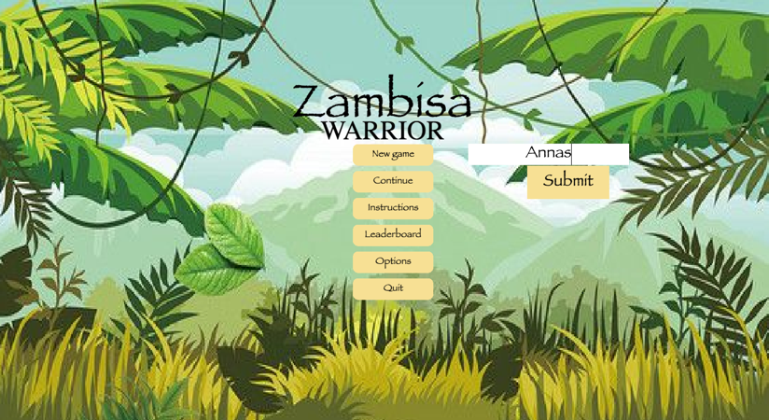

The Home page comes with 6 gaming options. The gaming options which include.
New game: This button option allows the user to begin a new game from ground level 1.
Continue: This button option is to permit the user to resume a saved game maintaining the previous high score attained.
Instructions: This button option uncovers a list of possible actions the main player can perform in a game session. The button option also provides a concise description player’s heads-up display.
Leaderboard: This button option provides a list of high scores from various players ranging from the first position which is the player with the highest score to the player with the least score.
Options: This button allows the user to set a game preference for a game session.
Quit: This button allows the user to exit the game app.

User Controls
The game starts in an initial state of princess Anthonia being at rest.
(Princess Anthonia at rest )
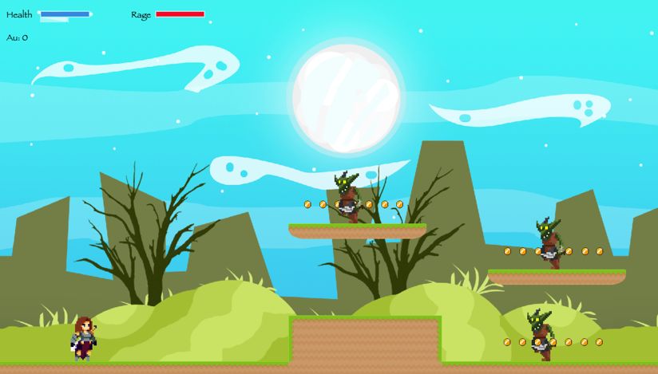

Here, the user would have to press the left arrow key on the keyboard to move left.
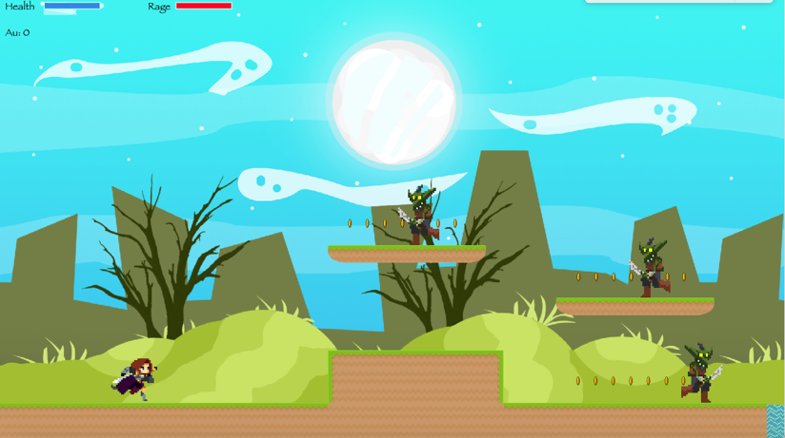

The user would have to press the right arrow key on the keyboard to move to the right.
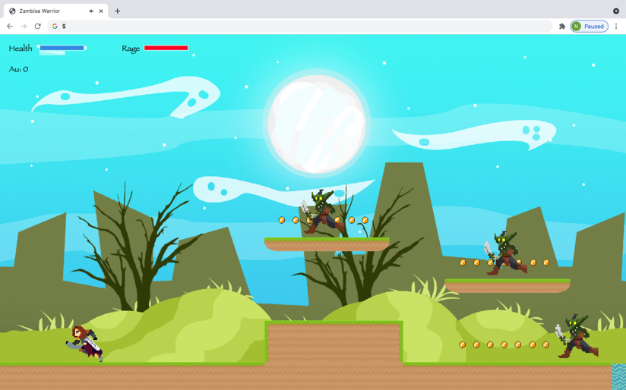

Action Controls
- Attack: To activate the attack action from Princess Anthonia, on the keyboard click on the spacebar key. This control wipes out the opponent character obstacles that would potentially kill the main character and end the game.
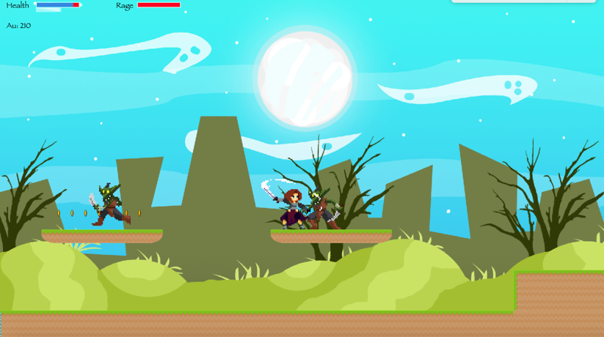
- Defense: To activate the defence action from princess Anthonia, on the keyboard click on “S” alphabet key. This control guards the main character from being susceptible to the opponent’s attack. When the opponent character obstacles attack princess Anthonia in this invincible mode, her health remains intact.
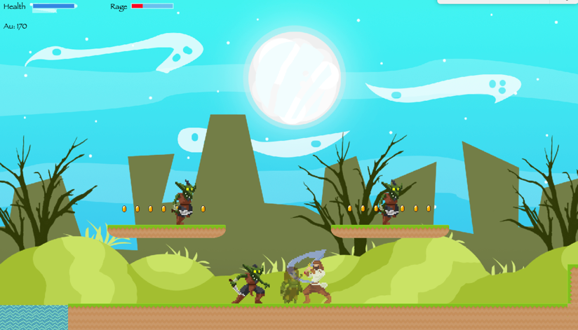

Pause/Play
To pause/play the game, the user can click on the “P” alphabet key on the keyboard which would prompt the user with the option of exiting the game session by clicking on the “Home” button. This prompt also consists of the options to change the game preference with sound enablement options. To resume the paused game, the user would be required to click on the “P” resume the game session.

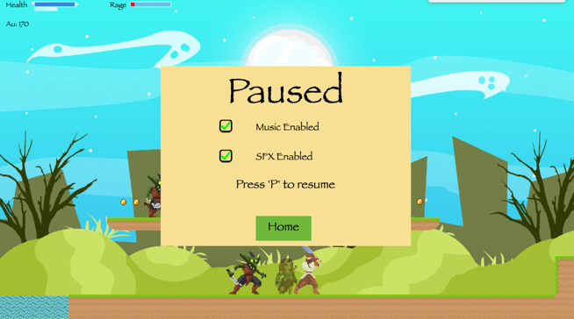

Exiting the Game

The user can exit the game by tapping on the Quit button provided on the homepage.

Back Story

Far away in the west of Africa lies a remote kingdom somewhere north of Nigeria called
Zambisa. Zambisa kingdom is well known for its vast lands, wildlife, treasures, and treacherous
forest. King Alhaji Musa Mai Gemu, son of King Alhaji Abdul Mai Gemu, son of Alhaji Zakari
Mai Gemu is the current ruler of the Zambisa kingdom. Usually, the crown passes down to the
first son of the king. There has been chaos in the kingdom lately because king Alhaji Musa Mai
Gemu has been very ill, and none of the healers have been able to heal him. That is just one of
the problems. The king has no heir to the throne as he only has two daughters, princess Anthonia
Zara Mai Gemu, the elder one, and princess Saratu Zoey Mai Gemu. Although princess Anthonia
has trained all her life to become a warrior, the land people don't still think she is fit to be the
heir to the throne. Princess Anthonia faces all this rejection as a result of her Caucasian maternal
lineage and the fact that she is a woman. Amidst all this drama, A dark lord called Damuwa has
been taking advantage of the king's illness to cause havoc in the forest areas. He is gradually
moving towards the main town area. He plans to overthrow King Musa. Now Anthonia must set
out to defend her land from this evil creeping into their land. To gain her people's blessing, she
must accomplish this mission alone.

